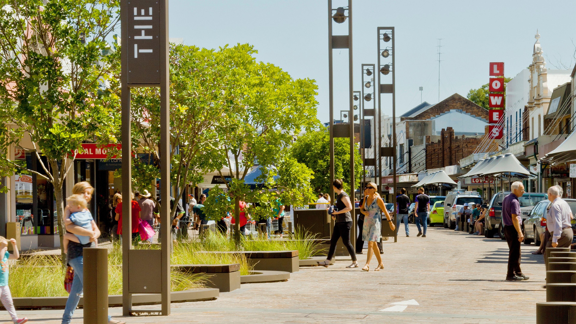

Acknowledgement of Country
Transport for NSW acknowledges the traditional custodians of the land on which we work and live.
We pay our respects to Elders past and present and celebrate the diversity of Aboriginal people and their ongoing cultures and connections to the lands and waters of NSW.
Many of the transport routes we use today – from rail lines, to roads, to water crossings – follow the traditional Songlines, trade routes and ceremonial paths in Country that our nation’s First Peoples followed for tens of thousands of years.
Transport for NSW is committed to honouring Aboriginal peoples’ cultural and spiritual connections to the land, waters and seas and their rich contribution to society.

Quick Facts
[Fill in table with relevant and available information]
Project Quick Facts
Project Type: | [e.g., Main street improvement – pilot and testing]
Project Stage: | ☐ Strategic Design ☐ Planning ☐ Design and Delivery  ☐ Operations & Maintenance
Project Scale: | ☐ Block/ Street ☐ Neighbourhood/ Corridor ☐ Precinct/ Subdistrict  ☐ Town/ District ☐ City/ Region/ Network
Project Cost: | [e.g., $100,000]
Funding Source:
Status: | [Include completion date/ month/ year if completed, or current stage and approximate % level of completion if still in progress]
Client: | [Include If relevant]
Project Team
Awards/ Recognition | [Include If relevant]
Supporting Information | [Include link to relevant website page or any relevant documents]

What is the project, its vision and who was involved?

[Insert summarizing heading]
[What is your project, what collaboration processes were used and how has a shared vision helped you to achieve your desired outcome?]
[Insert images or graphics of the project in the box below.]
[Insert image/ graphic caption]

Why was a Movement and Place approach used?

[Insert summarizing heading]
[How useful was analysing the context of both movement and place in achieving your project outcomes?]

How was the Movement and Place Framework used?

[Insert summarizing heading]
[How did the Movement and Place Framework allow you to establish a shared vision and balance movement and place outcomes, and how did this approach help address any project issues, opportunities, and trade-offs?]
For example, this can include:
- The value of collaboration/ co-design processes/ tools. E.g., Built Environment Indicators
[Insert Images or graphics of engagement, inputs, and outputs in the box below]
[Insert image/ graphic caption]

What were the outcomes/ benefits of using a Movement and Place approach?

[Insert summarizing heading]
[What were the outcomes/benefits of using a Movement and Place approach?]
[Insert ‘after’ Image or graphic in the box below]
[Insert image/ graphic caption]

What were the lessons learnt?

[Insert summarizing heading]
[What were the project learnings from applying a Movement and Place approach?]

More information/ Supporting documents
[Include additional relevant supporting documents with the case study]
For example, this can include:
- Relevant supporting documents
- Further reading (media releases, website links, useful guides/policies used, final design drawings/ master plan drawings)
- Photos/Graphics, maps, videos (include credits)
- Stakeholder Feedback (quotes, testimonials, formal feedback)

Contact information
We appreciate your time in providing this information. Please include your contact details as we may get in touch with you to discuss your case study further.
Name:
Title:
Email:

