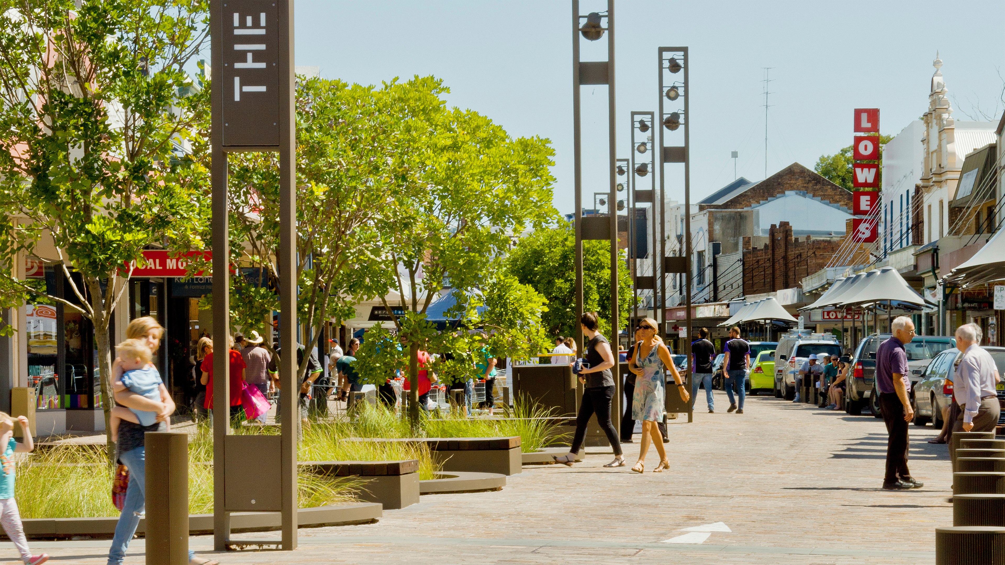

Acknowledgement of Country
Transport for NSW acknowledges the traditional custodians of the land on which we work and live.
We pay our respects to Elders past and present and celebrate the diversity of Aboriginal people and their ongoing cultures and connections to the lands and waters of NSW.
Many of the transport routes we use today – from rail lines, to roads, to water crossings – follow the traditional Songlines, trade routes and ceremonial paths in Country that our nation’s First Peoples followed for tens of thousands of years.
Transport for NSW is committed to honouring Aboriginal peoples’ cultural and spiritual connections to the land, waters and seas and their rich contribution to society.
Document information
Position
Project Name:
Senior responsible Officer:
Agency Head:
Delivery Agency:

Document version control
Project specific document history
Version | Amendment | Amendment date | Amended by

Supporting documentation
Project-specific documentation (other than this report)
Version | Amendment | Amendment date | Amended by

Introduction

The NSW Movement and Place Framework
The NSW Movement and Place Framework guides practitioners in the design, planning, delivery, and operation of streets and roads. It explains how to create contextually relevant proposals that balance various movement types with place-based considerations.

The Movement and Place Collaboration Report
Project teams following a Movement and Place process produce a Collaboration Report. This document demonstrates how they engage with local stakeholders, develop a detailed understanding of local place and movement characteristics, and deliver outcomes that will provide broader benefits to the community.

How to use this template
This template can help practitioners to record their activities as they follow the Movement and Place Core Process. It is intended to be used as a guide for the information that should be captured during all stages of the project. Different types of projects may find some sections more or less relevant, so project teams should use their judgement to produce a Collaboration Report that best represents the nature of their project in its context.

The Movement and Place Core Process
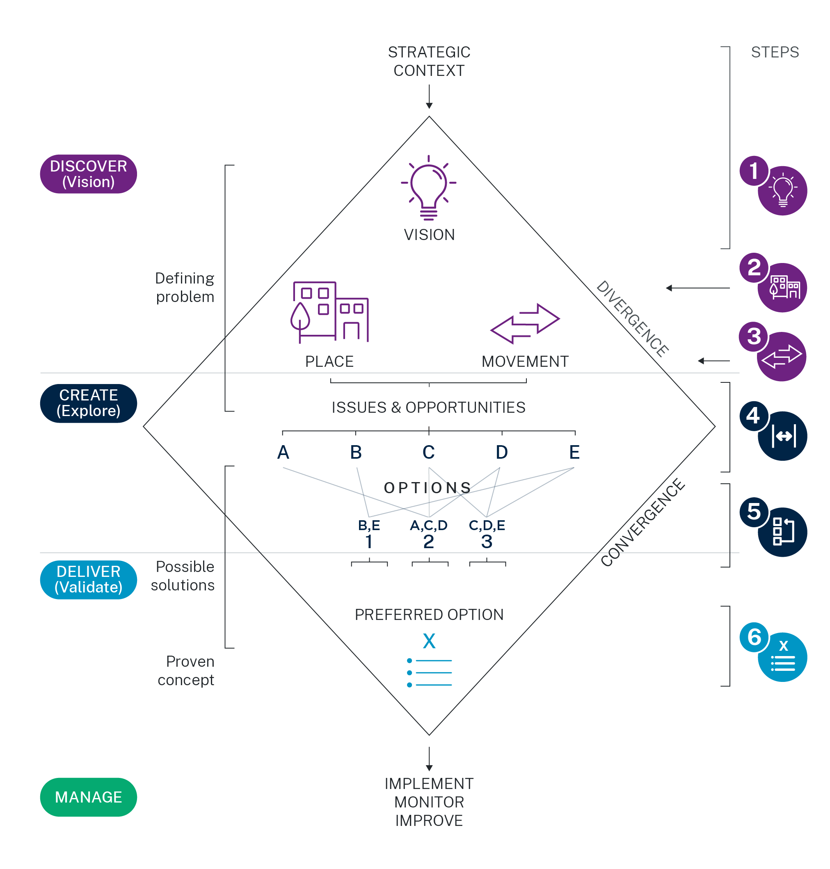
‘Taking a movement and place approach’ involves a design and planning process. The structure and content of this template is aimed at prompting project teams as they follow the process without being prescriptive.
The process is iterative and can involve project teams moving forward and back through the design process in response to relevant information that emerges over time.
These experiences will need to be documented to illustrate how the project investigations have led to an emerging preferred design proposal.

The six steps in the core Movement and Place process

Supporting guidance
For more information, please refer to the Movement and Place guidance on the Movement and Place website and in supporting documents:
- Aligning Movement and Place
- Practitioner’s Guide to Movement and Place
- Evaluator’s Guide to Movement and Place

Project summary

Project Scope
[Describe project study area, context, phase, and scale here]
[Please list work commissioned to inform the wider context of the project or plan, including specialist reports; studies; data; assessments informed by the identified social and cultural, environmental, and economic factors]

Core Project Team
Name | Title | Organisation | Responsibility

Movement and Place Application
[Describe in one paragraph how movement and place was used in the project here]
Summary of approach
Step | Date completed | Stakeholders involved | Outcome
Establish the project scope, vision, objectives, and evaluation criteria |  | - Organisation 1  - Organisation 2  - Organisation 3  - Organisation 4  - Organisation 5 | [Summary of how this step informed the project]
Understand Place |  | - Organisation 1  - Organisation 2  - Organisation 3  - Organisation 4  - Organisation 5 | [Summary of how this step informed the project]
Understand Movement |  | - Organisation 1  - Organisation 2  - Organisation 3  - Organisation 4  - Organisation 5 | [Summary of how this step informed the project]
Overlay and discuss conflicts, issues, and opportunities |  | - Organisation 1  - Organisation 2  - Organisation 3  - Organisation 4  - Organisation 5 | [Summary of how this step informed the project]
Develop options |  | - Organisation 1  - Organisation 2  - Organisation 3  - Organisation 4  - Organisation 5 | [Summary of how this step informed the project]
Chose preferred option |  | - Organisation 1  - Organisation 2  - Organisation 3  - Organisation 4  - Organisation 5 | [Summary of how this step informed the project]

Table of Contents
Introduction 4
The NSW Movement and Place Framework 4
Project summary 6
Project Scope 6
Core Project Team 6
Movement and Place Application 6
Vision 10
Objectives 10
Movement and Place indicators assessment 11
Step 1: Establish the scope, vision, objectives, and evaluation criteria 12
Analysis inputs 12
Stakeholder engagement 13
Step 2 Understand place 14
Place analysis 14
Place analysis map 15
Place intensity map 16
Step 3 Understand movement 17
Movement analysis 17
Movement analysis map 18
Movement function map 19
Steps 2 and 3 Understand place and movement 20
Stakeholder engagement 20
Step 4 Overlay and discuss conflicts, issues, and opportunities 21
Movement and Place issues and opportunities map 21
Movement and Place map 22
Stakeholder engagement 23
Step 5 Develop options 24
Option 1 25
Option 2 28
Option 3 31
Step 6 Preferred option 34
Performance Assessment Tool 34
Actions 34
Steps 5 and 6 develop options, and choose the preferred option 35
Stakeholder engagement 35
Consensus 35
Trade-off 35

Document control
Authors | <insert name of author/s>
Document owner | <e.g., Senior Specialist (Planning & Assessment)>
Approved by | <e.g., Executive Director, Environment and Sustainability>
Document number | <e.g., EMS-XX-GD-XXXX>
Branch | <e.g., Environment and Sustainability>
Division | <e.g., Safety, Environment and Regulation>
Review date | <insert review Month Year - usually two years from approval>
Superseded documents | <insert documents that are superseded by this document (if any)>

Versions
Version | Amendment notes

Vision
[Document the vision as a clear, concise, and contextually responsive statement]

Objectives
[Provide a list of place-based objectives for the project or plan below]
 | Objective | Movement and Place indicator | Target
1
2
3
4
5

Movement and Place indicators assessment
[List selection of performance indicators, including core, supplementary, and project-specific indicators]
[One paragraph description of how movement and place performance will change from existing to target state]

[Placeholder for visual output of option assessment]

[Demonstrate how performance of place will change before and after intervention.
Provide this as a separate appendix.]

Step 1: Establish the scope, vision,
objectives, and evaluation criteria

Analysis inputs
Identify what analysis inputs are required to understand place and understand movement in the study area.
For example, this can include:
- Data sets
  - Movement and Place Built Environment Indicators
  - NSW Spatial Planning information and GIS layers
  - Any proprietary data available or generated for the project
- Evidence documents
  - State, regional, district, or local planning strategies
  - Transport plans
  - Place plans
  - Precinct or master plans

Analysis inputs:  Data set or evidence document | Source | Comments

Stakeholder engagement
[List stakeholders and/or community involved in shaping the vision, objectives, and evaluation criteria at the outset of the project or plan]
[List workshops and/or meetings that were organised to bring stakeholders together]
Workshop/Meeting (date, location)
Stakeholder present |  | Vision |  | Supported view | Alternative view
Workshop/Meeting (date, location)
Stakeholder present |  | Vision |  | Supported view | Alternative view
Workshop/Meeting (date, location)
Stakeholder present |  | Vision |  | Supported view | Alternative view

Step 2 Understand place

Place analysis
[Summarise analysis of place on one page focusing on what elements of the place need to be addressed to achieve the movement and place vision. Consider all the elements of place.]

Elements of place:

Physical form
[the study area, its built and natural environment, as well as existing and proposed land uses]

Meaning
[character, views, landscape setting, history and heritage, social context and how these might change with the stated vision and objectives]
[Refer to guidelines Beyond the Pavement (RMS 2014) and Local Character and Place Guideline (DPIE 2019)]

Activity
[commerce, retail, manufacturing and activities like tourism, different uses and users, hours of operation, volumes of people and any other specific activities, tasks or behaviours related to specific uses such as education or health]

Place analysis map
Produce a Place analysis map that identifies:
Amenity and use
- Intensity of activities, including existing or desired activities on the street
- Destinations and points of interest, including public and private open spaces, community facilities, and significant institutions such as schools and universities, hospitals and medical centres, etc.
- Existing and proposed land uses
- Approved and potential development opportunities

Access and connection
- The street network layout, including any
- Activity and speciality street types
- Pedestrian crossings, including existing links, desire lines, and off-street links such as mid-block paths and arcades
- Existing and proposed infrastructure

Character and form
- Areas of cultural significance, including Aboriginal names, places, and objects
- Built form types including diversity, massing, and street interface
- Heritage items

Green and blue
- Topography and waterways
- Tree canopy and landscape
- Green Grid routes

Comfort and safety
- Vehicle speed, noise, and air pollution
- Night-time economy areas
- Any natural hazards, or resilience features
- Important map information

Place intensity map
Produce a Place intensity map that identifies:
- Proposed changes to amenity and uses, access and connection, character and form, green and blue, and comfort and safety (such as demographic trends, master planning changes, or catalytic infrastructure investment)
- Proposed temporal changes such as night time economy areas, etc.
- Resultant changes to the physical form, activity, or meaning of the place
- Any issues and opportunities that are likely to result from the change
- An assessment of issues and opportunities for the place considerations for streets and roads (for example, community expectations identified through consultation, strategic links identified in an LSPS, or the discovery of new place opportunities that could enhance the amenity and vibrancy of the neighbourhood)

Step 3 Understand movement

Movement analysis
[Summarise analysis of movement on one page focusing on what aspects of movement need to be addressed to achieve the movement and place vision. Consider all the factors of movement]

Types of movement:

Within place
[who travels within the place, when they do so and what they are accessing, how people travel within the place will need to be addressed to achieve the vision]

To/from place
[who travels to and from the place, when they do so and where they are going from/coming to, how the ways people enter the place will need to be addressed to achieve the vision]

Through place
[who travels through place, when they do so and how they travel, how this will need to be addressed to achieve the vision.]

Movement analysis map
Produce a Movement analysis map that identifies:
- Networks for each mode of movement
  - Walking
  - Cycling
  - Public transport (including routes and stops of any rail, light rail, bus, or ferry services)
  - Freight
  - Private motorised vehicles
- Interchange nodes
- Destinations that drive demands for mobility, including their primary access points
- Safety hotspots (identified through crash history), separated by type (pedestrian FSI, cyclist FSI, driver FSI etc.)
- Kerbside activity or desired kerbside activity (such as car parking, loading or servicing, or outdoor gathering)
- The map may also identify temporal travel patterns across the day, week and year including weekday morning and afternoon peaks, lunch times, night-time activities, and weekend peaks.
This map should consider the types of movement on streets or roads, including:
- Within place – indicate the primary routes people use to travel within the place
- Through place – indicate the primary routes people use to travel through the place
- To/from place –indicate volumes of people that enter the study area at each key location
As with movement networks, these may co-exist along the same street segment.

Movement function map
Produce a Movement function map that shows the planned future primary movement network prior to movement and place workshops based on local and strategic planning intent, including:
- Proposed route changes to movement networks;
- Proposed changes to movement systems, including the placement of stops, crossings, destination access points, road geometry etc.
- Proposed temporal changes (speed, dynamic allocation etc.)
- Resultant changes to the proportion of movement within, through, or to / from place
- An assessment of issues and opportunities for movement considerations for streets and roads, for example, adjustments to speed, new modal filters in the existing street network, new crossings to align with existing pedestrian desire lines, pinch point interventions, etc.

Steps 2 and 3 Understand place and movement

Stakeholder engagement
[List methods used to involve the community, other stakeholders, and subject matter experts in movement and place analysis – including inputs from consultation, interviews, site visits etc.]
[List workshops and/or meetings that were organised to bring stakeholders together]
Workshop/Meeting (date, location)
Stakeholder present |  | Vision |  | Supported view | Alternative view
Workshop/Meeting (date, location)
Stakeholder present |  | Vision |  | Supported view | Alternative view
Workshop/Meeting (date, location)
Stakeholder present |  | Vision |  | Supported view | Alternative view

Step 4 Overlay and discuss
conflicts, issues, and opportunities
[One page summary of issues and opportunities to inform the case for change]

Movement and Place issues and opportunities map
Produce a Movement and Place issues and opportunities map that consolidates the assessments made from the place analysis and the movement analysis.
Identify where issues and opportunities can be addressed, including potential inclusions in the scope of the current project, and where there is alignment with the project vision and objectives. For any ideas that are out of scope, identify which stakeholder groups may be involved in addressing these issues and opportunities, and forward your assessment on to those parties.

Movement and Place map
Produce an integrated Movement and Place map that identifies how movement and place will need to be addressed to achieve the vision.
Include a street environment classification.

Stakeholder engagement
List the method used to involve stakeholders in the discussion that led to an agreed set of issues and opportunities and Movement and Place Map.

Workshop/meeting (date, location)
Stakeholder | Issue | Supported view | Alternative view | Agreed view

Workshop/meeting (date, location)
Stakeholder | Issue | Supported view | Alternative view | Agreed view

Step 5 Develop options
[One page summary of validated options, sub-options and scenarios tested]

Option 1
[Half page description of Option 1]

[Half page description of how Option 1 performed against movement and place indicators]
Map of Option 1
[Insert Map of Option 1]

Option 1 Movement and Place indicators assessment
Indicator

Green and Blue
[Brief description of how the indicators for green and blue performed against target]

Amenity and Use
[Brief description of how the indicators for amenity and uses performed against target]

Character and Form
[Brief description of how the indicators for character and form performed against target]

Comfort and Safety
[Brief description of how the indicators for comfort and safety performed against target]

Access and Connection
[Brief description of how the indicators for access and connection performed against target]

Option 2
[Half page description of Option 2]

[Half page description of how Option 2 performed against movement and place indicators]
Map of Option 2
[Insert Map of Option 2]

Option 2 Movement and Place indicators assessment
Indicator

Green and Blue
[Brief description of how the indicators for green and blue performed against target]

Amenity and Use
[Brief description of how the indicators for amenity and uses performed against target]

Character and Form
[Brief description of how the indicators for character and form performed against target]

Comfort and Safety
[Brief description of how the indicators for comfort and safety performed against target]

Access and Connection
[Brief description of how the indicators for access and connection performed against target]

Option 3
[Half page description of Option 3]

[Half page description of how Option 3 performed against movement and place indicators]
Insert map of page 3
[Insert Map of Option 3]

Option 3 Movement and Place indicators assessment
Indicator

Green and Blue
[Brief description of how the indicators for green and blue performed against target]

Amenity and Use
[Brief description of how the indicators for amenity and uses performed against target]

Character and Form
[Brief description of how the indicators for character and form performed against target]

Comfort and Safety
[Brief description of how the indicators for comfort and safety performed against target]

Access and Connection
[Brief description of how the indicators for access and connection performed against target]

Step 6 Preferred option
[Outline preferred option, including the rationale for the assessment]

Performance Assessment Tool
Provide information on the inputs and outputs from the Movement and Place Performance Assessment Tool.

Actions
[List agreed action required and refer to implementation strategy to deliver preferred option]

Steps 5 and 6 develop options,
and choose the preferred option

Stakeholder engagement
[Summary of stakeholder feedback and discussion that led to the preferred option]
- Identify the common ground between stakeholders.
- Identify any areas of difference, the objections raised, and decisions made; and
- List any criteria for reassessment of those decisions

Consensus
Position |  | Consultee(s) |  | Assumption/trigger for review

Trade-off
Position |  | Consultee(s) |  | Assumption/trigger for review

Sample graph colours
Chart title | Chart title | Chart title
Expenses ($millions)  Operating expenses: XXX  Major rail project expenses: XXX  Depreciation and amortisation: XXX  Grants and subsidies: XXX  Other expenses: XXX  Total: XXX | Expenses ($millions)  Operating expenses: XXX  Major rail project expenses: XXX  Depreciation and amortisation: XXX  Grants and subsidies: XXX  Other expenses: XXX  Total: XXX | Expenses ($millions)  Operating expenses: XXX  Major rail project expenses: XXX  Depreciation and amortisation: XXX  Grants and subsidies: XXX  Other expenses: XXX  Total: XXX

FY20XX-XX ($millions)
Net Result: XXX
Revenue: XXX
Expenses: XXX
Other comprehensive income: XXX

